**Birla Institute of Technology and Science,Pilani**

**CS F212 Database Systems**

**Lab No # 9 A**

*************************************************************************************

1. Introduction to MongoDB

* MongoDB is a source-available cross-platform document-oriented database. Here records are stored as documents to provide scalability and flexibility that are required in querying and indexing.
* MongoDB is classified as a NoSQL ( Not Only SQL) database program that refers to any non-relational database. And uses JSON-like documents(meaning fields can vary from document to document and data structure can be changed over time).

1. Installing MongoDB on Windows-10 64-bit Version

MongoDB installation tutorials are available for Linux, Mac platforms as well.

Install MongoDB Community Edition on Windows

Go to the following link for download.

https://www.mongodb.com/try/download/community

2.1 Download the installer. Latest version is 4.4.1

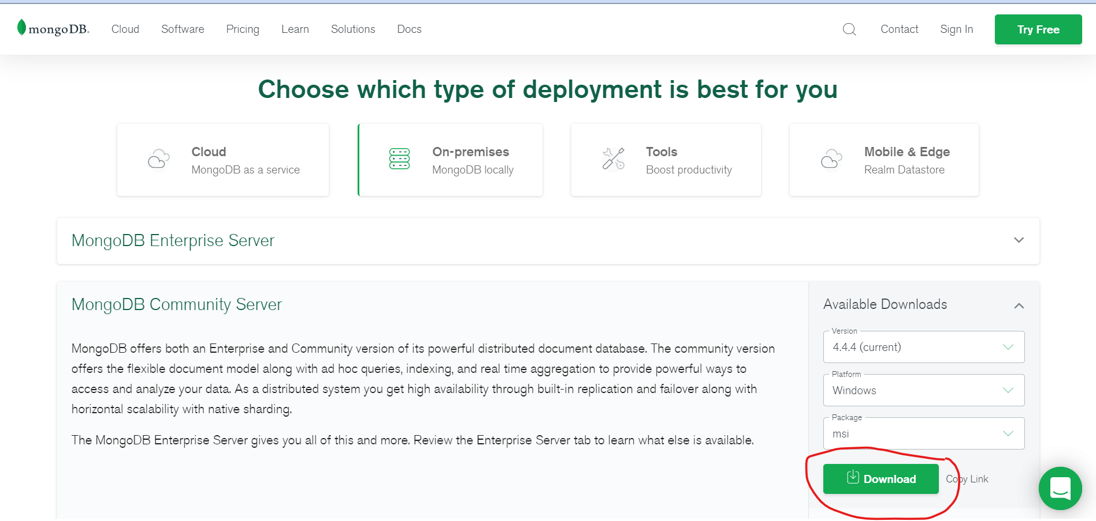

#### 2.2 Run the MongoDB installer.

2.3 Click on Next and accept the licence agreement.

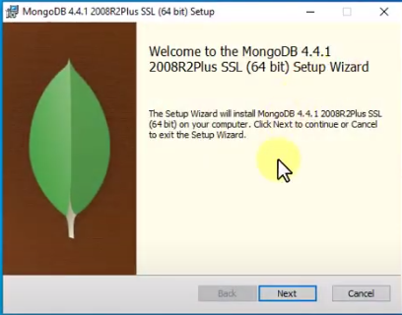

#### 

2.4 Select Complete setup type.

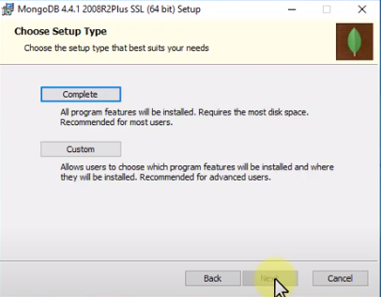

2.5 Edit the service configuration as given below, And Select Run service as Network Service user.

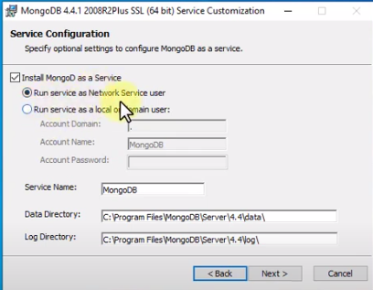

2.6 Install Mongo Compass and click on Next.

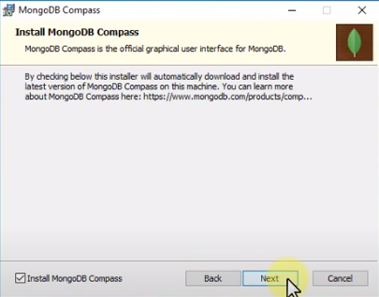

2.7 Install MongoDB version 4.4.1 and Finish the installation.

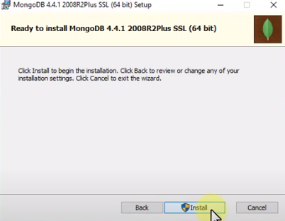

3. Configuring MongoDB

3.1 Goto the path where MongoDB has been installed. Go upto bin folder.

By default it is C:\Program Files\MongoDB\Server\4.4\bin

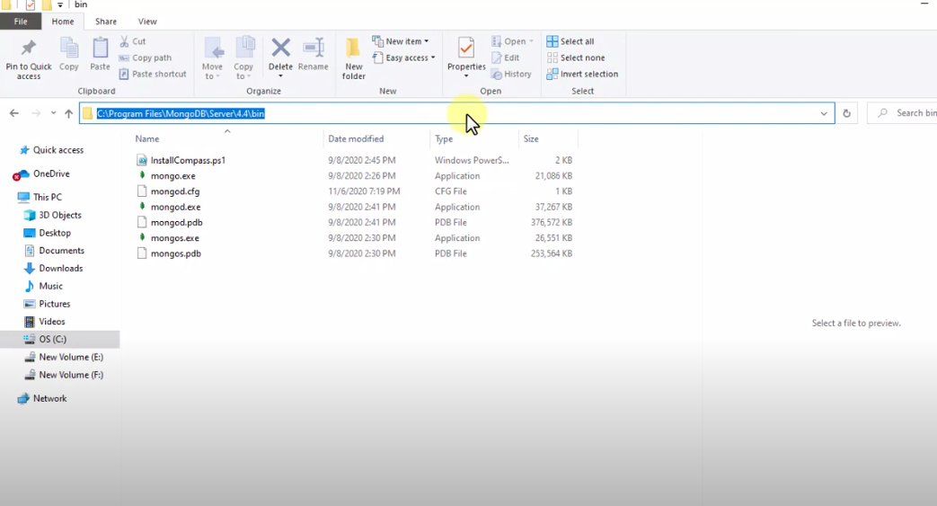

3.2 Create a Directory. Goto C: Drive and create a ‘Data’ folder and inside it create a ‘db’ folder.

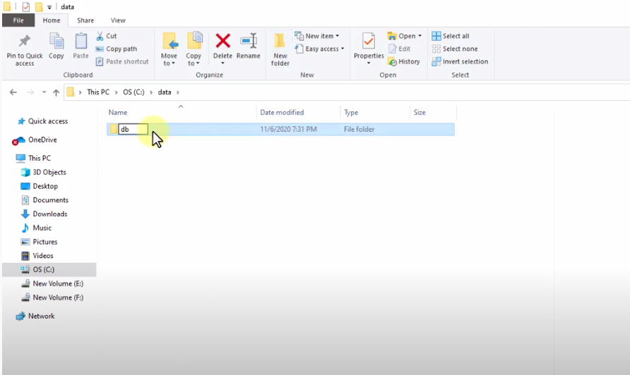

3.3 Goto Command Prompt, change the directory where the mongodb.exe has been stored. And run command ‘mongod’. This will start MongoDB.

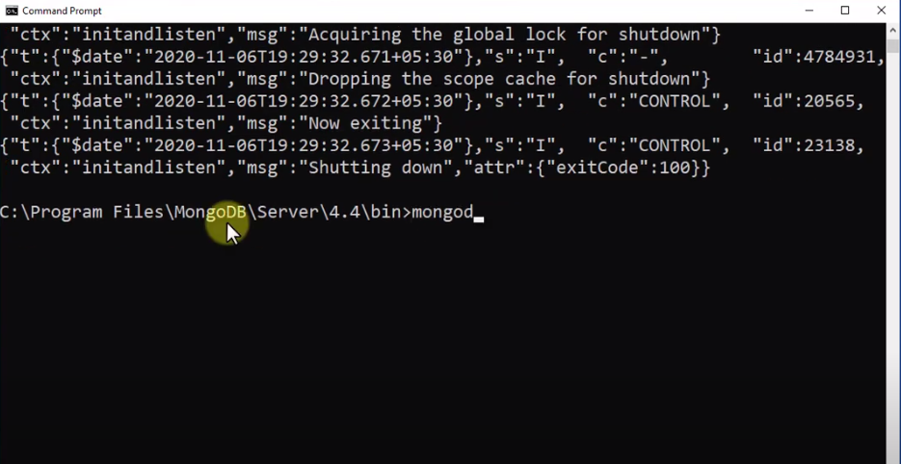

3.4 Open new Command Prompt, and change the directory with the same path (or you can simply change the SYSTEM PATH variable) and run the command mongo. This will connect ‘mongo’.

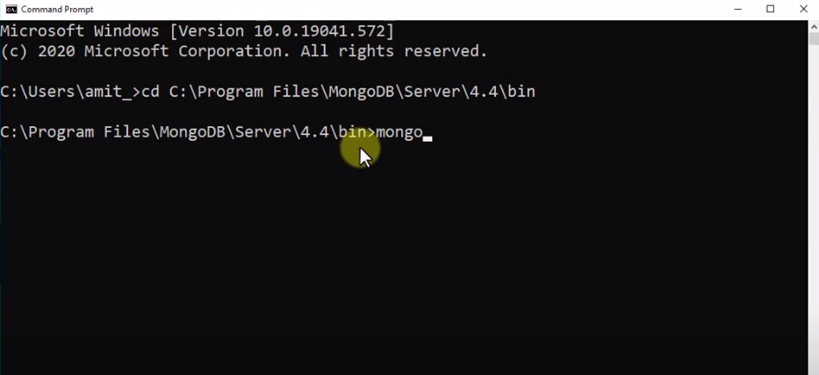

Successfully connected server will tells the MongoDB server Version (Latest 4.4.4)

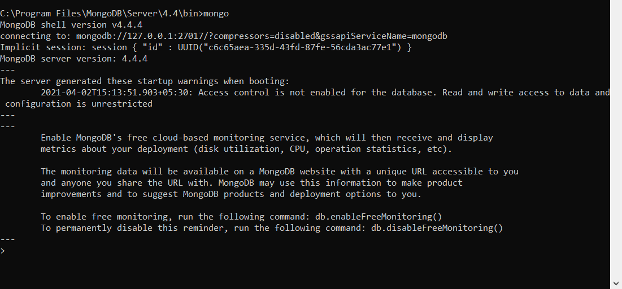

4. How is MongoDB better than MySQL?

One of the main benefits of MongoDB over **MySQL** is its ability to handle large unstructured data. MongoDB is **faster**. People experience real world **MongoDB** performance mainly because it allows users to query in a different manner that is more sensitive to workload.

3 main difference between MongoDB and MySQL are in terms of:

1. Flexibility in schema
2. No/Few relations required in database
3. Greater performance

## 5. When to Use MongoDB vs MySQL

The core differences between these two database systems are significant. Choosing which one to use is really a question of approach rather than purely a technical decision.

MySQL is a mature relational database system, offering a familiar database environment for experienced IT professionals.

On the other hand, MongoDB is a well-established, non-relational database system offering improved flexibility and horizontal scalability, but at the cost of some safety features of relational databases, such as referential integrity.

**So which one should to choose?**

**In term of User Friendliness:**

MongoDB data storage philosophy is simple and immediately understandable to anybody with programming experience. It stores data in collections with no enforced schema. This flexible approach to storing data makes it particularly suitable for developers who may not be database experts.

Whereas, MySQL is a common choice for users for using traditional SQL scripting, designing solutions for relational databases. Relational databases may also be a better choice for applications that require very complex but rigid data structures and database schemas across a large number of tables.

**In term of Performance:**

It is difficult to compare Relational vs non-relational Databases. But, it has been noted that MySQL is faster at selecting a large number of records, while MongoDB is significantly faster at inserting or updating a large number of records.

**In term of Flexibility:**

MongoDB is way more flexible as compared to MySQL. The schema less design of MongoDB documents makes it extremely easy to build and enhance applications over time, without needing to run complex and expensive schema migration processes as you would with a relational database.

***********************************END***************************************